LIBSPACE
PROJECT DOCUMENTATION

INTRODUCTION:
Project Title: “LibSpace – Library Management System”
Team Members:
1. Gopika.L
2. Kaviya.M
3. Kavipriya.p
4. Monika.S

API IMPLEMENTATION SCREENSHOTS:
The following screenshots demonstrate the successful execution of LibSpace APIs using Thunder Client in Visual Studio Code. The screenshots show the request body and corresponding server responses.

- REGISTER API:

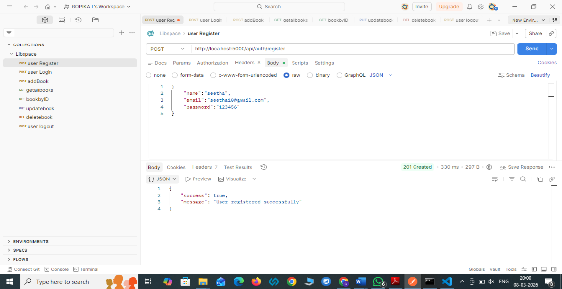

* This API allows a new user to create an account in the LibSpace system.
* The user provides details such as name, email, and password in the request body.
* After successful registration, the system stores the user data in the database and returns a JWT authentication token along with user information.

- LOGIN API:

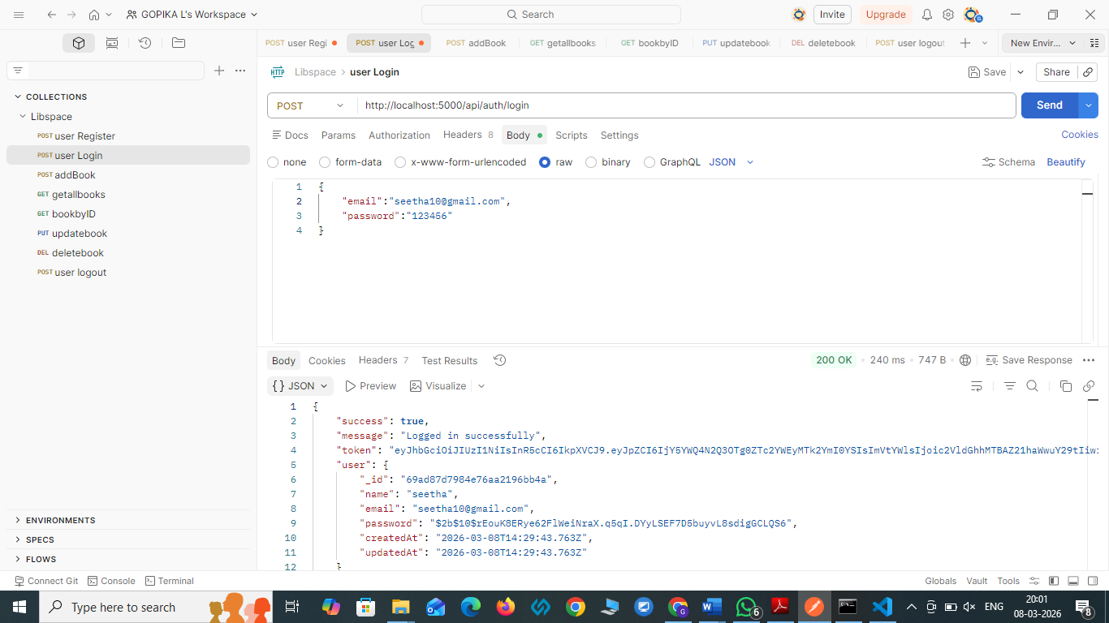

* This API allows an existing user to log in to the LibSpace system.
* The user provides email and password in the request body.
* If the credentials are valid, the system returns a JWT authentication token and user details, which are required to access protected APIs.

- ADD NEW BOOK:

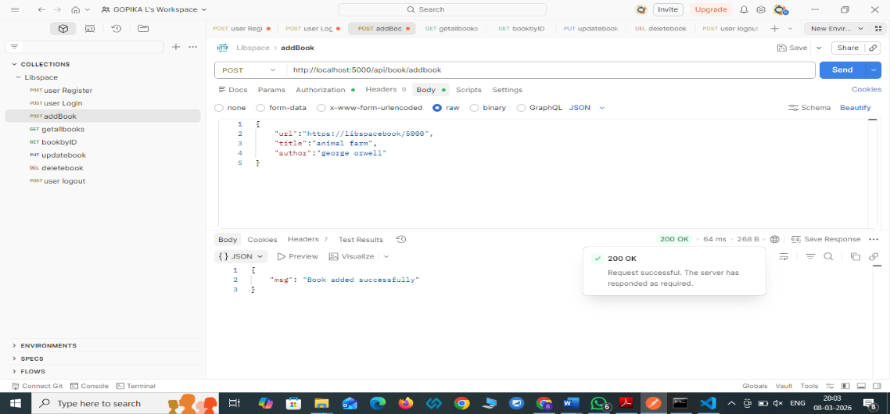

* This API allows an authorized user (such as an admin or librarian) to add a new book to the library system.
* The request body includes book details such as title, author, category, and publication year.
* After successful creation, the book information is stored in the MongoDB database and returned in the response.

- GET BOOKS :

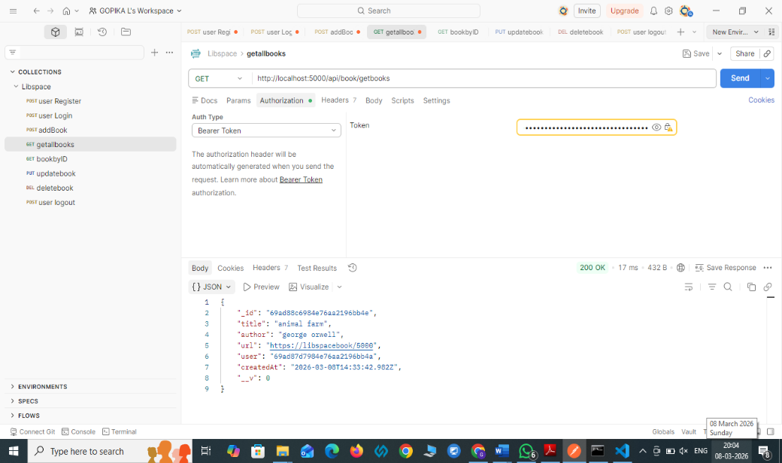

* This API retrieves the list of all books available in the LibSpace system.
* The request is sent to the server without requiring specific parameters.
* The system fetches all book records stored in the database and returns them in the response.
* This helps users view the complete collection of books available in the library.

- GET BOOK BY ID API:

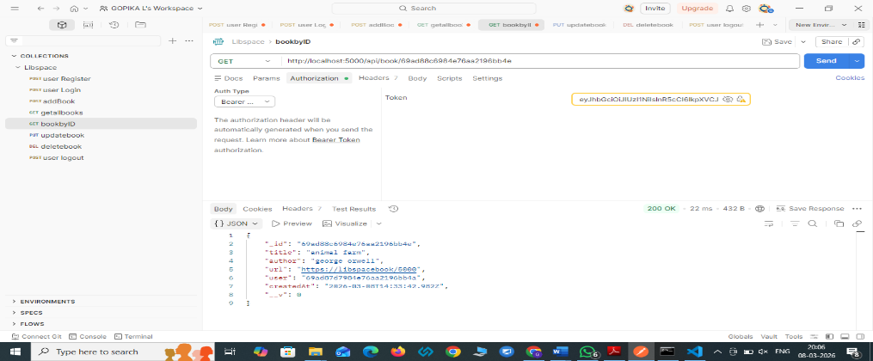

* This API retrieves the details of a specific book using its unique book ID.
* The book ID is passed in the request URL.
* The system searches the database for the matching book record.
* If the book exists, the system returns details such as title, author, category, and publication year.

- UPDATE BOOK DETAILS:

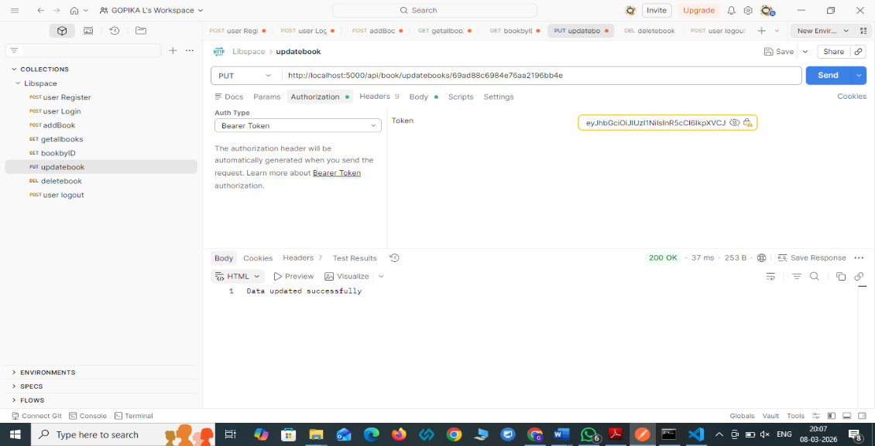

* This API allows the user to update the details of an existing book in the system.
* The book is identified using its unique book ID in the URL.
* Updated details such as title, author, or category are saved successfully in the database.

- DELETE BOOK:

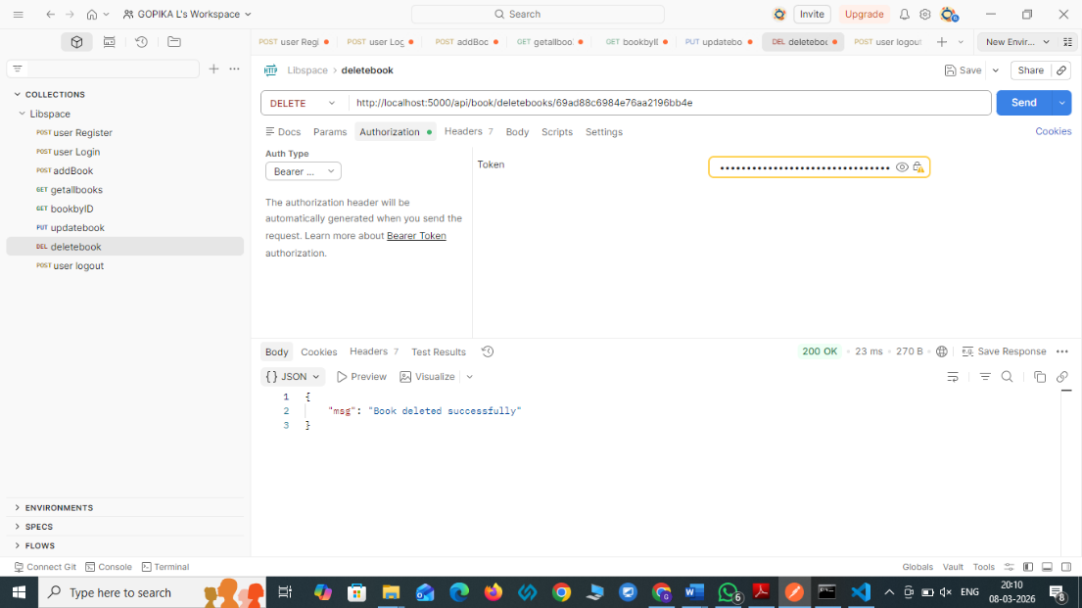

* This API allows an authorized user to delete a specific book from the LibSpace system.
* The book is identified using its unique book ID.
* Once deleted, the system returns a confirmation message indicating that the book was removed successfully.

- LOGOUT API:
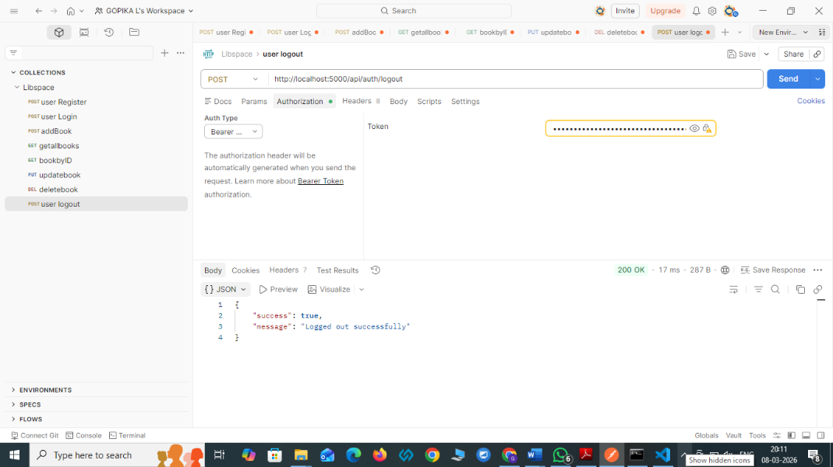

* This API allows the user to log out from the LibSpace system securely.
* The system invalidates the current authentication token used by the user.
* After logging out, the user will no longer be able to access protected APIs without logging in again.
* A confirmation message is returned indicating that the user has logged out successfully.

